Home
Why Speech Therapy Works?
Speech Therapy Works has been providing home based speech therapy in Singapore since 2006.
We offer high-quality personalized speech therapy to our clients across all ages in the comfort of their own homes.
We have a combined experience of more than 30 years. Our vast experience and network in both the public and private healthcare sectors allow us to provide comprehensive assessment and treatment to our clients.
We have often been consulted for second opinion for complex cases by both clients as well as healthcare professionals from Singapore and in the region.
We are able to reach out to the community across different language and dialect groups as we are proficient in English, Malay, Mandarin, Cantonese, Hokkien and Hainanese.

Our Values
We desire to see our clients achieve better quality of life through the services we offer. Our therapists are experienced and selected based on their area of specialties.

ABOUT US

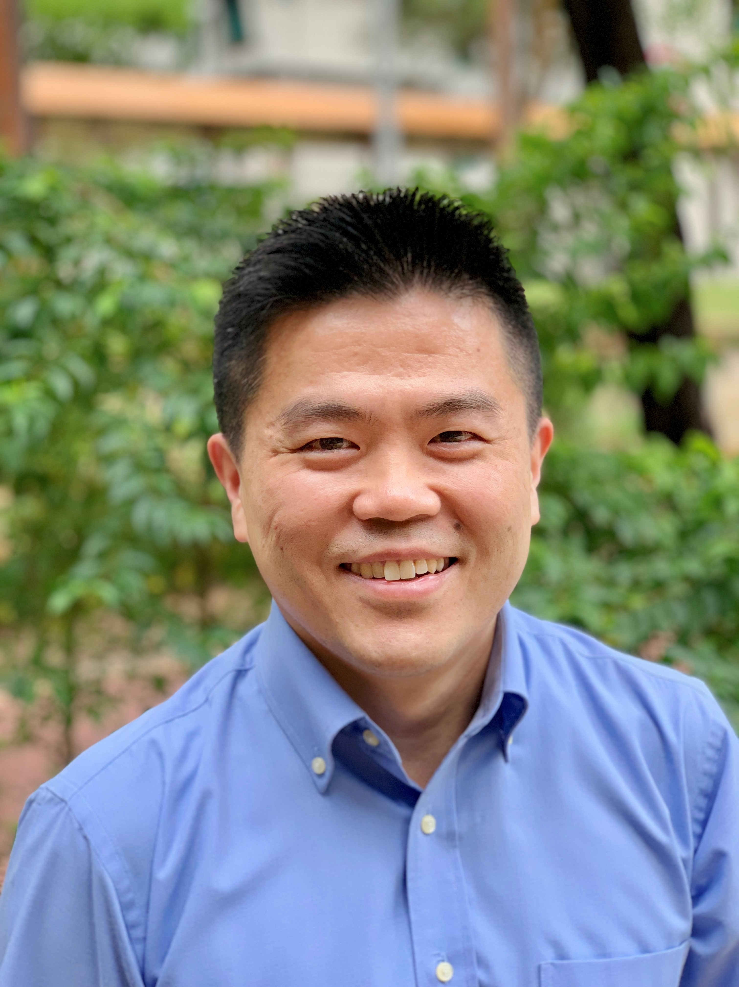

Yoon Wai Lam
Bachelor of Speech Sciences (Hons)
Fully Registered under AHPC
- Co-founder, Director
- Senior Principal Speech-Language Therapist
- Invited Lecturer, MSc (Speech and Language Pathology), National University of Singapore
- Examiner for the Speech-Language Therapy Qualifying Examination Board
- Inventor of the award winning Chin Tuck Against Resistance (CTAR) exercise
- Reviewer of the Dysphagia Journal

Wai Lam has close to 20 years of experience in adult speech, language and swallowing therapy. He is the inventor of the Chin Tuck Against Resistance (CTAR), a swallowing therapy exercise that is currently practiced worldwide. He has trained hundreds of speech therapists both locally and regionally. He is often consulted by speech therapists and other healthcare professionals for complex cases involving both speech and swallowing difficulties in Singapore and overseas.
He began his career in Singapore General Hospital (SGH) in year 2001. He was in charge of the dysphagia clinic, setting up of sEMG clinic, and Prosthetic Speech and Swallowing Clinic (PSSR) in collaboration with the National Dental Centre (NDC). In year 2006, he moved on to set up Speech Therapy Works to provide home therapy services and locum services to the local hospitals and nursing homes. He was also a part-time lecturer at the National University of Singapore (NUS), Masters in Speech-Language Pathology (SLP) programme from 2008-2018.
Wai Lam has developed training programmes and has been conducting trainings and workshops on dysarthria and dysphagia in Singapore and overseas. He continues to supervise and provide support to the speech therapists in local hospitals and from abroad. He has been actively supporting the development of dysphagia management in Malaysia. In 2019, he was invited as a co-trainer at the distinguished Langmore Foundation FEES Course & Post Laryngectomy Rehabilitation Course at Tata Memorial Hospital, Mumbai, India.
Wai Lam’s research papers has been presented at local and international conferences and published in international journals. His research on CTAR exercise has won the first price poster presentation at the Dysphagia Research Society at Seattle, USA in 2013. Wai Lam’s CTAR research papers have been widely cited in international journal papers and text books (ResearchGate March 2020: ~ 80 citations). Wai Lam is also a reviewer of the Dysphagia Journal.
Wai Lam has developed various therapy protocol & therapy tools. His dysphagia therapy protocols for brainstem stroke, late effect from radiotherapy for nasopharyngeal cancer or head & neck cancer, and swallowing difficulties due to anterior cervical osteophytes have helped many patients to improve their swallowing functions. In 2018, he has successfully developed a smart swallowing device prototype in collaboration with the Singapore University of Technology and Design (SUTD). Research and development are ongoing.
Certification in:
- Videofluoroscopy (VFS)
- Fiberoptic Endoscopic Examination for Swallowing (FEES)
- Surface Electromyography Biofeedback (sEMG)
- Vitalstim Therapy
- McNeill Dysphagia Therapy Program (MDTP)
- Tracheostomy Management
- K-Taping® Speech and Language Therapy
- Lee Silvermann Voice Therapy (LSVT)
- Lessac-Madsen Resonant Voice Therapy (LMRVT)

Languages:
- English
- Mandarin
- Cantonese
- Hokkien
- Malay
- Bahasa Indonesia

Low Ai Wei
Bachelor of Speech Sciences (Hons)
Fully Registered under AHPC
- Co-founder, Director
- Senior Principal Speech-Language Therapist

Ai Wei has more than 15 years of experience in Speech Therapy. She began her career as a Speech and Language Therapist in Singapore General Hospital in 2004, where she gained valuable experience assessing and managing both adults and paediatric cases across various disorders involving speech, language, and swallowing issues. In 2008, Ai Wei joined Speech Therapy Works in providing locum services to community hospitals (Ang Mo Kio - Thye Hua Kwan Hospital, Bright Vision Hospital), nursing homes, and a private paediatric clinic. She has also been providing home based therapy for both adults and children.
In addition to being a clinician, Ai Wei has supervised and trained junior Speech Therapists and Speech Therapy students on clinical placements in conducting Clinical Bedside Swallowing Evaluation and paediatric speech and language management. She is also actively giving on-going talks to healthcare professionals on “Introduction to Dysphagia Management”.
Ai Wei is trained and experienced in carrying out various programs and intervention approaches suitable for children with speech and language delay, articulation and phonological disorder, children with developmental apraxia of speech, children with autism spectrum disorder, children with hearing loss, children with auditory processing issues, and childhood stuttering. She has been working with a varied paediatric caseload from infants to school-age children.
Certification in:
- Videofluoroscopy (VFS)
- Fiberoptic Endoscopic Examination for Swallowing (FEES)
- Tracheostomy Management
- Vitalstim Therapy
- Lessac-Madsen Resonant Voice Therapy (LMRVT)
- PROMPT (Basic Level)
- Hanen Programme (It Takes Two To Talk & More Than Words)
- Dementia Management (Understanding and Preventing Dementia)

Languages:
- English
- Mandarin
- Cantonese
- Hokkien
- Hainanese
- Malay

What we offer

Home Based Speech Therapy
We believe in providing comprehensive speech therapy at our clients’ convenience and our success has been proven since 2006. A client’s home provides a more conducive environment for learning of new skills and/or generalization of new skills learnt into real life situations. Not forgetting, the home provides the most naturalistic environment to observe interaction between the client and their caregivers.
We understand the needs and challenges of being a caregiver. Most caregivers are working thus sending your love one to the clinic for an appointment often result in taking leave or time off from work. This adds unnecessary stress to caregivers as not all employers will be as understanding towards the needs of being a caregiver. Some clients require intensive therapy sessions to optimize treatment results. However, frequent travelling to the clinic can be tiring for both the client and their caregiver(s).
With the advancement of technology, we can instantly turn every home into a computerized speech and swallowing gym to carry out intensive speech and/or swallowing therapy. As such, we can bring the clinic to the clients' home!
We are the first to introduce Surface Electromyography Biofeedback (sEMG) for home speech and swallowing therapy in 2006 and we have proven our success through the improvements of the functions and the quality of life for most of our clients.
After all these years, our goal remains the same and simple:
To improve quality of life through our best practice and better outcome.

Testimonials
Although not regulated for AHPC, we have decided adhere to the Ministry of Health Private Hospitals and Medical Clinics (Advertisement) Regulations on not to publish patients’ testimonials online.
Previous cases and outcomes can be discussed during consultation.

